|  |  |
| --- | --- |
| Low-Level Design | |
|  | |
| 17-07-2023Java: Banking application | Siddharth MoneShikha Verma |

|  |  |  |
| --- | --- | --- |
| Serial number | Table of content | Page number |
| 1. | Introduction | 3 |
| 2. |  |  |
| 3. |  |  |
| 4. |  |  |
|  |  |  |
|  |  |  |

**1. Introduction**

1.1. What is a Low-Level design document?

The goal of LLD or a low-level design document (LLDD) is to give the internal logical design of the actual program code for Bank application System. LLD describes the class diagrams with the

methods and relations between classes and program specs. It describes the modules so that the

programmers can directly code the program from the document.

1.2. Scope

Low-level design (LLD) is a component-level design process that follows a step-by-

step refinement process. This process can be used for designing data structures, required software.

architecture, source code and ultimately, performance algorithms. Overall, the data organization

may be defined during requirement analysis and then refined during data design work.

**2. Architecture**

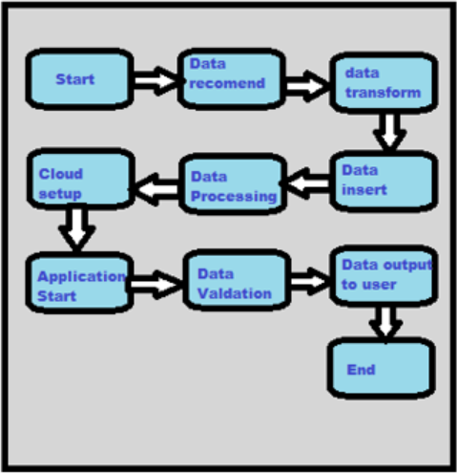

**3. Architecture Description**

**Class Diagram:**

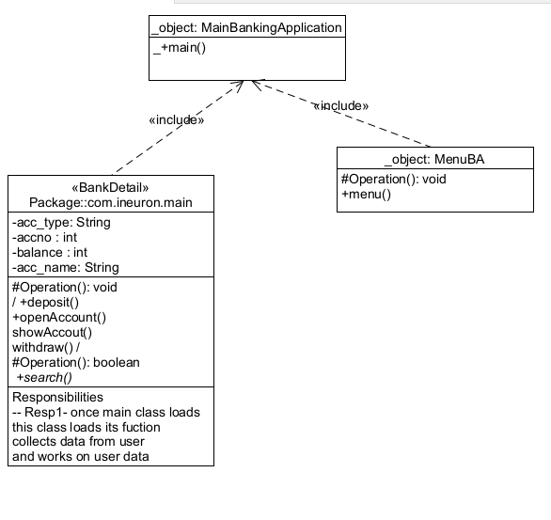

**Use-Case Diagram:**

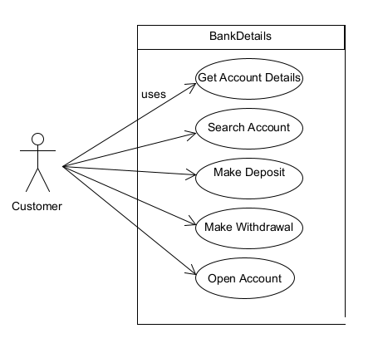

Class diagram and Use-Case Diagram shows that how application work. As we see that in Class diagram we are using 3 classes. MainBankingApplication is a main class which contain main method and Execution starts from here.Other two classes BankDetail and MenuBA extrends main classs. BankDetail class contain all the operation and MenuBA display which operation can perform by using this Application.

Use Case diagram shows the uses of Application.We can deploy our model into cloud.